CD Assignment 2

-------------------------------------

Name: Yash Oswal

Div: B Roll no.: 38

SRN: 201901226

-------------------------------------

Design a Lexical analyzer for the subset of C Language using LEX or FLEX. Read input from file. Also Create symbol table. Upload single file with input , output and source code.

Input Code:- input.txt

int main(){

int n=8, m=10, add;

n=n/2;

m=2*m;

add=n+m;

return 0;

}

Output: 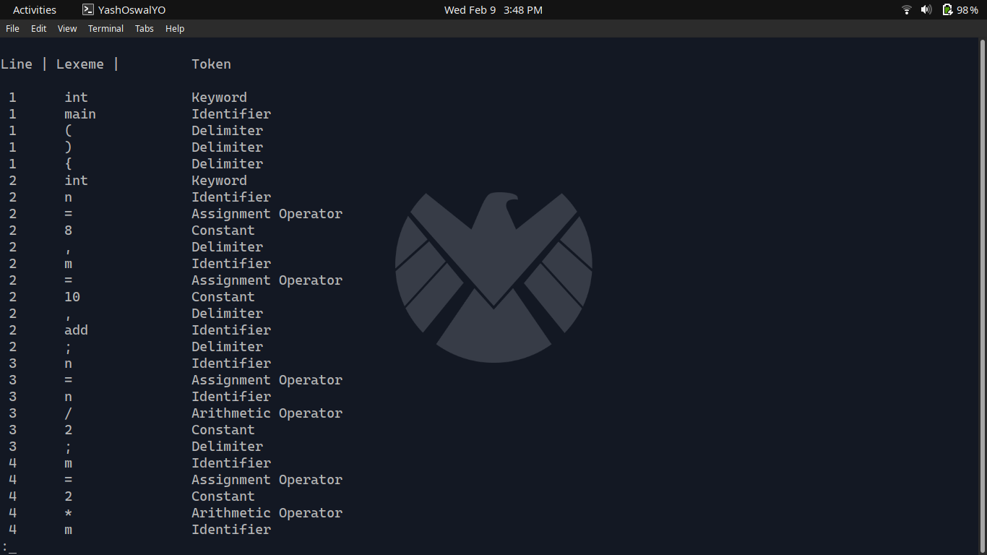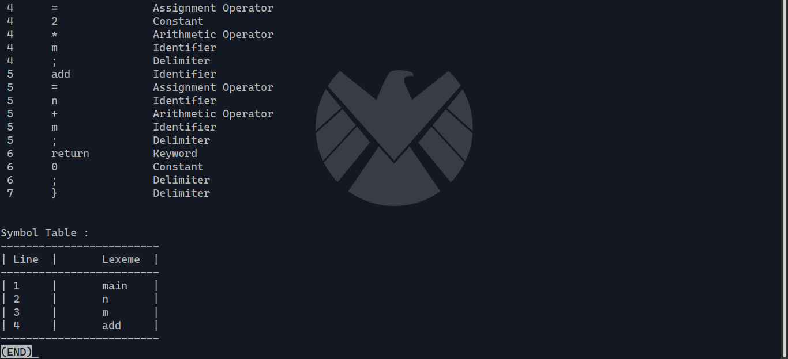

Source Code :-

%{

#include <stdio.h>

#include<string.h>

struct symEntry{

int index;

char lexeme[30];

};

struct symEntry symtable[30];

int sti=0;

int line=1;

void put_symtab(){

int j;

if(sti==0){

symtable[sti].index=sti+1;

strcpy(symtable[sti].lexeme,yytext);

sti++;

return;

}

for(j=0;j<sti;j++){

if(strcmp(symtable[j].lexeme,yytext)==0){

return;

}

}

symtable[sti].index=sti+1;

strcpy(symtable[sti].lexeme,yytext);

sti++;

}

%}

letter [a-zA-Z]

number [0-9]

delim ["|']

%%

"int"|"if"|"double"|"long"|"goto"|"static"|"float"|"short"|"while"|"char"|"const"|"void"|"else"|"return"|"printf"|"scanf" {printf("\n %d\t%s \t\tKeyword", line,yytext);}

"("|")"|"{"|"}"|"["|"]"|";"|"," {printf("\n %d\t%s \t\tDelimiter", line, yytext);}

{delim} {printf("\n %d\t%s \t\tDelimiter", line, yytext);}

"+"|"-"|"*"|"%"|"/"|"++"|"--" {printf("\n %d\t%s \t\tArithmetic Operator",line, yytext);}

"=="|"<"|">"|"<="|">=" {printf("\n %d\t%s \t\tRelational Operator",line, yytext);}

"=" {printf("\n %d\t%s \t\tAssignment Operator",line, yytext);}

{letter}+|({letter}{number})* {printf("\n %d\t%s \t\tIdentifier",line, yytext);put_symtab();}

{number}+ {printf("\n %d\t%s\t\tConstant",line, yytext);}

{number}+{letter}+ {printf("\n %d\t%s \tERROR This is ILLEGAL",line,yytext);}

{delim}({letter}|{number})*{delim} {printf("\n %d\t%s \tString Constant/Literal",line,yytext);}

"\n" {line++;}

%%

void print_st(){

int j;

printf("\nSymbol Table : \n");

printf("-------------------------\n");

printf("| Line\t|\tLexeme\t|\n");

printf("-------------------------\n");

for(j=0;j<sti;j++){

printf("| %d\t|\t%s\t|\n",symtable[j].index,symtable[j].lexeme);

}

printf("-------------------------\n");

}

int main(int argc, char* argv[])

{

yyin = fopen(argv[1], "r");

printf("\nLine | Lexeme | \tToken\n");

yylex();

printf("\n\n");

print_st();

fclose(yyin);

}

int yywrap()

{

return 1;

}